To facilitate a united provider voice for best practices, advocacy, partnerships and networking.

December 20, 2018
Maureen Harwood
550 W 8th Ave.
Anchorage, AK. 99501

Dear Maureen:

AADD recognizes that SDS was charged with setting up the Individual Supports Waiver (ISW) as a replacement for grant services in the Medicaid Reform bill of 2016. SDS has worked diligently on accomplishing this task. The Center for Medicare and Medicaid Services (CMS) was slow to approve the amendment for the ISW in Alaska, taking five additional months past the anticipated approval date (from January to May/2018). The DPA backlog of Medicaid eligibility determination has also slowed the process for SDS, providers, care coordinators and families and individuals. While recognizing the complexity of the conversion from grant funds to Waiver Medicaid, the transition is not proving to be smooth.

AADD is alarmed about the gap in services for recipients for whom grant funds expire January 1, 2019. This gap has the potential to create a difficult public relations scenario for the new administration and SDS. We would like to be part of the solution in averting any negative publicity resulting from families and individuals losing services. With January 1, 2019, a short two weeks from now, AADD would like to offer three recommendations:

Recommendation:
- Grant funds could be extended, as offered previously, by moving unspent ISW Medicaid dollars back into general funds to allow an extension of grant services for those not yet drawn, in process, or not yet determined ISW eligible.
- Assure providers in writing, via an E-Alert, that submitted Support Plans that are awaiting approval or other paperwork will be authorized (i.e., Service Authorizations with effective start dates) as of the Level of Care date or October 1st 2018, whichever date is later.
- Make the Safety Net funds (through Stone Soup) flexible enough to be utilized by those awaiting ISW approval, not limited to those who have completed the difficult process.

Providers have documented a number of difficulties with the current ISW process in working with Care Coordinators to submit Support Plans. Care Coordinators are struggling with having to develop a lengthy support plan, the equivalent to an IDD Plan of Care, while being paid a significantly reduced rate for that service. DPA is significantly backlogged in determining Medicaid eligibility. Some families have waited a year for their Medicaid eligibility. Thank you, SDS, for working with Health Care Services to expedite the 60 ISW Support Plans that have been submitted that are awaiting Medicaid approval. Getting the necessary paperwork gathered for an ICAP (Level of Care determination) has also created lengthy delays. The required neuro psych evaluation for recipients outside of Anchorage has proved very difficult. Recipients receiving ISW letters are also challenged with finding and obtaining care coordination services.

We want to share a few examples of the real life impact of the termination of the grant services.

Story 1
Male (mid-twenties) lives at home with his mother and does not have access to public transportation as he works on base. The provider agency used grant funds for job coaching and transportation to the jobsite on JBEAR. This is his only source of income. Because of his low DDRR score he has not been drawn for the ISW. Without job support and transportation onto JBER he will lose his job. The provider agency is having to determine whether they need to submit two weeks’ notice for the recipient to remain in good standing vocationally. (DVR is not an option as he has a job now).

Story 2
Male (mid -twenties) lives with a mother who doesn’t drive. He works at the dining hall at JBER. Public transportation is not an option. He has been drawn for an ISW and is in the LOC determination process. Because the mother didn’t understand the process, the organization (following multiple calls asking if she had received the ISW letter) was not informed that a Care Coordinator was selected. Now the Care Coordinator has resigned. If the agency had known the individual was drawn they would have been of significant assistance. Without the Supports Plan submitted the individual will lose his job as there are no funds to pay for coaching and transportation.

Story 3
This man has been supported by Hope since Aug 1985, when he was released form Harborview, where he was placed by the State of Alaska in his youth, although he was born on St Paul Island in the early 1960’s.
For the next 15 years he lived in foster care and supported apartments with onsite staff. In December 2000, he purchased a one bedroom condominium where he has received grant based supports with residential and community based services.
He receives about 6 hours per week for assistance with shopping and keeping appointments which have become more essential. In April 2018, he fell and broke his ankle so these supports became even more important to his recovery and maintaining independence. Natural supports and friends are already significant and help fill the gaps of these minimum paid supports. He is at significant risk of making poor choices and requiring higher cost medical attention without the maintenance of these supports.
His grant funded care coordinator has been working for the past year to secure evaluations and documentation in effort to qualify for ISW funding which would meet his current level. He has not been drawn for the ISW funding.
No funding for these minimal supports will be available to him on January 1, 2018 without either the CDDG extension or access to the safety net funds.

AADD is committed to working with SDS to assure that the most recipients possible retain their services. Providers and state staff feel the painful reality as individuals served for organizations, sometimes for 20 years are denied services effective January 1, 2019. We feel that the three recommendations listed above are important to support those with submitted Support Plans but also those drawn but who have not been able to obtain a care coordinator to develop and submit their Support Plan. Thank you for your hard work on this issue and for considering our recommendations.

Sincerely,

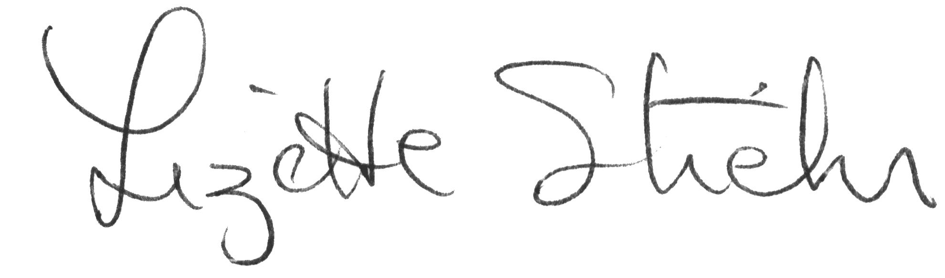

Lizette Stiehr
Executive Director, AADD

Cc: Deb Etheridge
Caitlin Rogers

