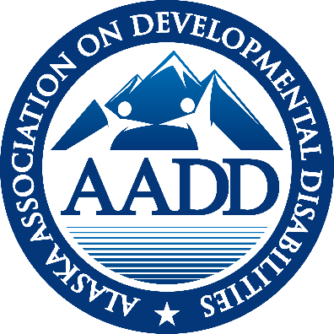

AADD
ALASKA ASSOCIATION ON DEVELOPMENTAL DISABILITIES

EXECUTIVE DIRECTOR REPORT
December 2020

NOTEWORTHY NEWS
- Governor’s Budget contained no reductions to SDS budget
- Heather Chord is the new IDD Unit Manager (replacing Caitlin Rogers)
- Self-Audit deadline extended to March 31, 2021
- Governor Dunleavy issued a 30 day Emergency Health Disaster Declaration from December 16th to January 15th

ATTACHMENTS:
- Impact of COVID-19 on Providers, presentation to the Mental Health Trust 1.6.21

SDS UPDATE
Provider Agreements (closed December 9th) with SDS now allow for an additional 33% reimbursement in addition to the billing rate for those recipients in isolation with COVID.
The COVID vaccine has arrived in Alaska. Health care workers and the Pioneer Home residents have been vaccinated. Group Home congregate setting are a part of the Phase 1a or the first distribution. The vaccine is not mandatory. Some providers have already set up clinics for vaccination for residents and staff.
SDS announced that Heather Chord is the new IDD Unit Manager, replacing Caitlin Rogers. Her 7.5 years at SDS and previous work in the field will serve her well in her new job.
CIR’s (Critical Incident Reports) for a staff member diagnosed with COVID are not required but it is recommended by SDS. Licensing has different requirements for those living in licensed homes.
SDS is working on 4 ECHO’s in the next year, with the Center for Human Development for individuals that experience developmental disabilities, their families and staff, or the DSP’s that work for you.
Background Checks remain slow. The Background Check Unit has agreed to attend the January AADD monthly meeting to discuss provisional checks and fingerprinting.
Appendix K remains in effect. And Governor Dunleavy’s a new Emergency Health Disaster from December 16th through January 16, 2021 means federal and state Emergency Health Disaster dates align.

MENTAL HEALTH TRUST AUTHORITY
AADD has been invited to share the impact of COVID on our providers with the Trustees on January 6th A copy of the talking points is attached to this report. ABHA and AgeNet are reporting as well.

Mental Health Trust Grant 8464.03 for FY21 is for $65,000. The three primary goals are:
- Advocate for a strong system and best practices through involvement with national trends and organizations.
- Change management support for leadership in provider organizations – membership voted for Leadership Consortium Training. Negotiations are underway.
- Support for Agency Sustainability and Work Force Development
Based on voting at our October virtual Face2Face meeting, AADD is utilizing Trust funds to bring the Leadership Consortium (University of Delaware) back to Alaska in April. This training is designed for key leadership. There will be 40 slots available. Due to the Trust funding and sponsorships the cost will only be $500 per person. (Note: the 2015 cost was $1,200/per person). Watch for the applications that will come out in January. We hope each organization will send at least one person. A PowerPoint about the Leadership Consortium is on the AADD website under miscellaneous.

Mental Health Grant 12039 -Technology Capacity Building from 6/1/20 to 4/30/20 for $50,000
AADD was granted funds for Champney Consulting to continue creating the infrastructure to embed technology as a support system and safety net for people with disabilities. AADD has subcontracted with Caryn Brunello with the Arc of Anchorage to host a number of webinars to keep expanding the use of remote supports.

Anchorage Community Foundation
AADD has received and spent a $51,500 grant. Northwest Strategies has developed dynamic 30 and 60 second spot for the recruitment of DSPs. An active ad campaign began December 21st to include TV, radio, digital ads, and the ADN. Ads will be placed in Anchorage/MatSu, Juneau, and Fairbanks. Kenai Peninsula (Kenai, Homer, Seward, Valdez), Southeast (Sitka, Ketchikan, Wrangell, Petersburg and Kodiak). Each ad ends with go to DSPHire. (See below)

Mental Health Trust Letter of Interest
AADD has been assured that the letter of Interest for $21,000 will be funded. This will support ongoing marketing from January to April of 2021 of the ads Northwest strategies developed.

DSPHire App
Cares Act funding through SDS has successfully funded DSPHire. Jake Carpenter has resigned his “day” job effective Christmas and will be working on the app/website full time. Jake is working diligently to fix the glitches. If you need assistance his email is < jake@appcare.ai> And it’s important that you register your DSP openings on the app. The ads, ending with go to DSPHire, begin December 21st and will continue through the rest of the fiscal year.

CFO and COMPLIANCE GROUPs
The CFO and Compliance groups will meet jointly in January to continue the conversation on electronic health record software. There were no meetings in December.

HOT TOPICS
No Hot Topics in December due to Christmas and the holidays.

WEBSITE
The December newsletter, November monthly report and a power point on the Leadership Consortium is posted on the website. Thanks to all the members who have registered for the members only access. If you are a member and have not registered go to: www.aaddalaska.org/wp-login.php?action=register
ADVOCACY Alaskans Standing For Medicaid A broad coalition of organizations that rely on Medicaid (including health, homelessness, food insecurity, Native Health, Mental Health Trust, Mat Su Health Foundation, ABHA, AADD and others) continues to meet weekly. The group is facilitated Jessie Meekins with the Primary Care Association.
Shared Vision Advocacy Coalition The Shared Vision has hosted a coalition of disability-related organizations. The group has met several times and have united around a core primary issue: Direct Support Professional workforce. A letter was drafted and shared with incoming legislators. The coalition is comprised of the following entities: the Key Coalition of Alaska, the Alaska Association of Developmental Disabilities, Peer Power, the Governor's Council on Disabilities and Special Education and the Statewide Independent Living Council.
ANCOR Briefings: ANCOR continues a 15 to 30 minute briefing of what is happening on the “hill” (federal congress) each Friday morning at 8:30. I attended three in December.
- Awaiting latest COVID Relief bill. Passed by the legislature, President Trump has different ideas. Passage unknown at this time.
- ANCOR has met with Biden transition team twice. One meeting focused on EVV in hopes of averting FMAP reductions if a state is unable to comply. A second meeting focused on workforce issues.
- Vaccine availability for folks with IDD and DSP’s was a major topic of conversation. Determined at a state level.
CALENDAR
January 5, 2020 AADD Board meeting 9 to 10
January 5, 2020 Care Coordination Meeting 10 to 11:00
January 14, 2020 AADD monthly meeting
January 20 & 21, 2020 Board Retreat 1:30 to 4:00 pm
January 21, 2020 CFO & Compliance Group 10 to 11
January 28, 2020 Hot Topics – to be determined

SUMMARY OF SDS ALERTS
December 4, 2020 E-Alert: Change to Support Plan Distribution Process
December 7, 2020 E-Alert: Provider Self-Audit Due Date Extension
December 7, 2020 E-Alert: Division of Vocational Rehabilitation taking applications for services
December 15, 2020 E-Alert: Recruitment Campaign for DSP’s begins next week
December 16, 2020 E-Alert: Complete Applications required for Personal Care Services
December 17, 2020 E-Alert: Clarification on Appendix K Extension of Respite and Chore Services
December 18, 2020 E-Alert: The Division of Vocational Rehabilitation is taking applications for services
December 18, 2020 E-Alert: ECHO Series on COVID Science for Individuals with Developmental Disabilities, their Families and their Support Teams Complete Applications required for Personal Care Services
December 17, 2020 E-Alert: Clarification on Appendix K Extension of Respite and Chore
December 18, 2020 E-Alert: The Division of Vocational Rehabilitation (DVR) is taking applications for services
December 22, 2020 E-Alert: ECHO Series on COVID Science for Individuals with Developmental Disabilities, their Families and their Support Team
December 28, 2020 E-Alert: COVID-19 Vaccination Information on Tier 3 Phase 1A and 1B
December 31, 2020 E-Alert: Additional COVID-19 vaccine arriving soon in Alaska: older Alaskans and front-line essential workers among those next in line
December 31, 2020 E-Alert: COVID-19 Vaccination Information on Tier 3 Phase 1A and 1B

Respectfully submitted,
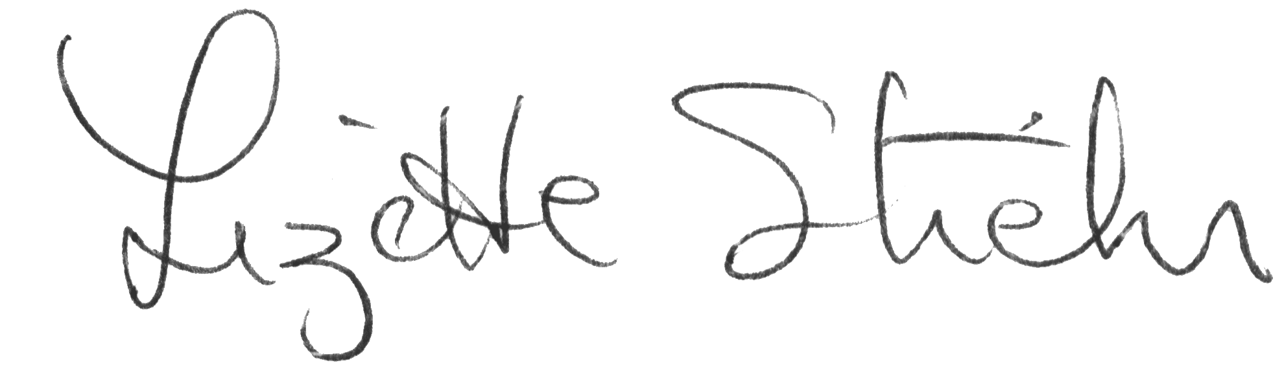
Lizette Stiehr
Executive Director, AADD

Talking points
Alaska Mental Health Trust
January 6, 2020
Impact of COVID-19 on Providers
(I have 10 minutes)

WORKFORCE
- Decrease in employee application due to COVID coverage and unemployment
- Quarantining is further limiting available workforce
- Increased overtime adding to stress to DSP to cover COVID related absences
- Increased leave do meet family needs for schooling, child care and quarantining
- Quitting to home school or provide child care
- Increased training costs due to compliance with COVID requirements and COVID training itself
- Providers must be super creative to maintain coverage
- Super creativity required to maintain adequate coverage and elivery of services safely

FISCAL SHORTALL
- Huge losses of revenue (lost services day habilitation, families choosing no services to limit exposure etc.)
- Salary costs for serving those with a diagnosis are 35 to 40% increased
- Staff are paid when quarantining
- PPE costs
- Cares funding long gone

FATIGUE
- Staff are fatigued, zooming is not what they do, they are “people for the people”, remote services difficult
- Administrators are worn out. Nine months of trying to stay in front of the firehose of information on COVID-19, funding options, the vaccine, the multi reporting all asking for different information
- Beneficiaries are worn out being isolated
- One provider asked how many suicide calls are you fielding?
- When was going to the hospital good for someone’s mental health? Only during the isolation of COVID, 9 months later
- Trying to implement the Shared Vision, yes it is your life, and now suddenly it’s no, you can’t choose, you have to isolate.

STATE PROCESSES SLOWED DOWN
- State workers are working from home and each bureaucratic process is much slower (i.e. licensing homes, background checks)

QUALITY MONITORING
- Concern that oversight agencies have been unable to visit home site for 9 months.
- Care Coordinators not going into homes so limited oversight

COMMUNITY SUPPORT
- Community support through the wearing of masks is important
- With the known increased mortality rate for individuals with developmental disabilities and the fact that many have underlying health conditions, their safety is paramount
- It would be ideal for there to be a statewide mandate for masks, while recognizing that with a mandate in Anchorage compliance is not consistent.
THE GOOD NEWS and what are we doing about it? With your help?
- Appendix K has allowed flexibility in a number of areas – remote services, remote visits, simplified plans and amendments and day hab in the home
- Trust funding has allowed the field to move years forward in terms of assistive technology from I pads to a wide variety of assistive technology
- The Alaska Community Foundation joined with the Trust to fund a marketing campaign for DSPs to entice them into the field. It began in December.
- Trust grant funds to AADD had begun a DSPHire app. Cares Funding through DHS is providing robust funding to allow full time work to fully develop the app with many possible supports for providers down the road (training offered, coordination with the background check unit).

