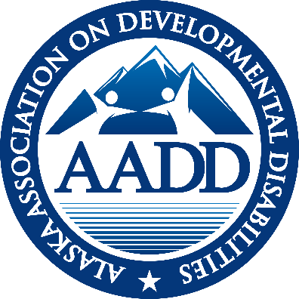

AADD
ALASKA ASSOCIATION ON DEVELOPMENTAL DISABILITIES

EXECUTIVE DIRECTOR REPORT
June 2021

NOTEWORTHY NEWS
- Waiting to see Alaska’s plan for the 10% FMAP increase. It is currently in the Governor’s office for review.
- President Biden has recommended a 400 BILLION infrastructure package for HCBS services. Congress has drafted and submitted a bill titled Better Care, Better Jobs for those funds. See what it contains below and know changes will be negotiated.

FEDERAL UPDATE
Better Care, Better Jobs: A proposal for transforming Home and Community Based services. This bill, just submitted to congress will operationalize the 400 billion dollars recommended by the President to impact HCBS services. The current version contains these options for states:

- 10% FMAP increase for 10 years (with planning time so it won’t overlap current bump)
- Establish in statute “direct support professional” as a professional classification (separate from personal care attendants and home health aides etc.) and direct the Department of Labor to establish a Standard Occupational Code for DSPs.
- Contain 100 billion to initiate an implementation planning process that includes stakeholders
- Require that state pay sufficient reimbursement rates to providers and review the rates every two years.
- Recruitment and retention funds for staff
- Commit to the establishment of a set of standardized quality measures within two years of the bill passing.

SDS UPDATE
10% FMAP Increase - The American Rescue Plan Act (ARPA) offered a 10% FMAP increase for HCBS services. Once guidance was released by the Center for Medicare and Medicaid Services (CMS) SDS held listening sessions the same week on May 20 and 21 with involved stakeholders. SDS worked rapidly to develop a plan based on that stakeholder input. The Division obtained a 30 days extension to allow for review of the plan by the Commissioner and the Governor’s Office. It has not yet been submitted to CMS. The deadline is July 12, 2020. The letter AADD submitted with recommendations was attached to last month’s monthly report. In quick summary AADD’s recommendations included:
- Workforce stabilization: 50% of funds should go toward DSP’s recruitment and retention support
- Transition support from institutions to the community
- Companion Services pilot project
- Add hours to the ISW waiver
AADD Care coordination recommendations were attached to May’s monthly report and included:
- Grants for CC to recoup pandemic expenses
- Adopt on-going flexibilities of Appendix K, particularly remote visits and the extended support plan
- Greater flexibility within Harmony – particularly goals
- Develop a contact/liaison at SDS for care coordinators with supervisory authority over IDD and NFLOC units to improve communication
- Grants are needed to hire and train new care coordinators
- Care coordination rates need to match increased responsibilities
Appendix K –With the federal Public Health Emergency extended to September 21, 2021, combined with Alaska’s approved 6 month extension of Appendix K, the earliest date the flexibilities expire is March 21, 2022. SDS agreed that not all services will be extended (i.e. simplified support plans currently expire in October). SDS promised to issue an E-Alert with clarification on any services that the state will terminate prior to the end of the extension.
Family Habilitation—Nothing has changed from last month. SDS is awaiting Steve Lutsky’s (HCBS Strategies) summary of stakeholder input from the Potential Changes to Residential Services webinars. SDS assured the membership that there will be another round of input once the feedback has been incorporated, prior to any final plan. AADD made significant recommendations including: 1) Grandfathering in group home providers that own their homes, 2) Allow providers to be become the Organized Health Care oversight Entity, 3) Increase the Family Habilitation Home rate, and 4) Define “live-in” staff in group homes. Letter containing AADD recommendations was attached to May’s monthly report.
Companion Services —No change. AADD has recommended that some of the 10% FMAP increase be dedicated to professional service contracts to pilot Companion Services.
Harmony – All Care Coordinators will be required to enter plans into harmony exclusively beginning July 1, 2021. Care Coordinators are going through the training now and it is time intensive and not set up well to allow person directed services. Goals are from a drop down menu for example and have limited character space for inputting

MENTAL HEALTH TRUST AUTHORITY
Mental Health Trust Grant 8464.04 for FY 22 is for $65.000. This grant contains the same three general goals as last years. It is signed and approved.
Mental Health Trust Grant 8464.03 for FY21 is for $65,000. The grant has received an amendment for a 3 month extension to September 31, 2021. This will allow for activities in the summer/fall. The three primary goals are:
- Advocate for a strong system and best practices through involvement with national trends and organizations. Supported HCBS Conference attendance (2 individuals), ANCOR Conference (4 individuals), V.J. Smith to keynote, Ben Drew to keynote
- Change management support for leadership in provider organizations. Hosted University of Delaware Leadership Institute attended by 32 individuals statewide.
- Support for Agency Sustainability and Work Force Development – Funding to support AADSP (Alaska Association on Developmental Disabilities) to meet in person for workforce planning in September.

Mental Health Trust Grant 12039 – Technology Capacity Building
Champney Consulting spearheaded the work for the Technology Capacity Building grant that was funded from April 1, 2020 to April 30, 2021. The final grant report was submitted to the Trust on June 30, 2021. The Final Report is attached to the email with this report as formatting won’t allow it to be attached here. It can also be found on the website.

COMPLIANCE GROUP
The Compliance Group met June 17th. Discussion topics included Human Rights Committee’s (the Arc of Anchorage has one) and what programs are opening what services. Serious concerns about the background check unit were articulated complicating workforce crisis with super slow approvals. Cost of Care concerns with regulations making providers responsible is going into effect August 1. SDS is planning a webinar (not yet announced) on this topic in mid-July. Also possible recommendation for the Hot Topics in August.

Clarification was requested around if the regulation saying that a provider cannot be required to do a self-audit the same year they are being audited by Meyers and Stauffer. Regulation 7AAC 169.115 states that “An enrolled provider who bills the department for services rendered during a calendar year shall conduct, once every two years, a review or audit of a statistically valid random sample of claims…..unless the provider is being audited under AS 47.05.200 (a).” And that citation refers back to the Meyers and Stauffer audits. Questions remain around what year is intended, same calendar year or the same fiscal year? No Compliance Group meeting in July.

CFO GROUP
The CFO Group met June 17th. There has been no feedback on the Cost Surveys. Forgiveness for PPP loans is just beginning with just one provider receiving forgiveness confirmation. One provider shared problems getting certified. Multiple questions around how often Meyers and Stauffer audits take place for individual programs and when do letters of notice go out. Will send email to Doug Jones requesting clarification. No CFO Group meeting in July.

HOT TOPICS
The Hot Topics call June 24th^{h} focused on the implementation of the Shared Vision by providers including suggestions such as adding the Shared Vision to your signature line or under your company logo. Suggested a steering committee of the major stakeholder groups move Shared Vision forward. Need to focus on deliverables.

ADVOCACY Alaskans Standing For Medicaid is a broad coalition of organizations that rely on Medicaid (including health, homelessness, food insecurity, Native Health, Mental Health Trust, Mat Su Health Foundation, ABHA, AADD and others). The group continues to meet weekly sharing legislative updates and federal information. Lizette and Michael generally attend for AADD.

ANCOR Briefings: ANCOR continues a 15 to 30 minute briefing of what is happening on the “hill” (federal congress) and the Administration each Friday morning at 8:30. I attended three in June.
- Better Care Better Jobs bill submitted on June 23 to operationalize the 400 billion infrastructure bill to support HCBS services. See first article in this report for content.
- Work requirements are being removed state by state.
- A new bill is being prepared for the Congress to make Home and Community Based Services a required service under Medicaid instead of optional.
CALENDAR
June 29, 2021 AADD Board meeting 9 to 10
July 6, 2021 Care Coordination Group 10:30 – 11:30
July 8, 2021 AADD Monthly Meeting 11:00 – 12:00
No Compliance, CFO or Hot Topics in July in recognition of SUMMER
October 19 & 20, 2021 Fall Face2Face meeting – hybrid at BP Center and zoom

SUMMARY OF SDS ALERTS
June 2, 2021 E-Alert: Applications are open for the 2021 Peer Power Self-Advocacy Summit
June 3, 2021 E-Alert: UPDATE: Cyberattack Update: Temporary Webpage Created for SDS
June 11, 2021 E-Alert: Waiver Renewals Update
June 11, 2021 E-Alert: Guidance on Congregate Residential Settings Updated
June 21, 2021 E-Alert: New Vaccine Resources for People with Intellectual and Developmental Disabilities
June 24, 2021 E-Alert: Payment rates for Medicaid Waiver and State Plan Services Increasing in FY22
June 30, 2021 E-Alert: Use Chrome to Connect with SDS’ Harmony Database
June 30, 2021 E-Alert: Care Coordinators and the SDS Harmony Data System

Respectfully submitted,
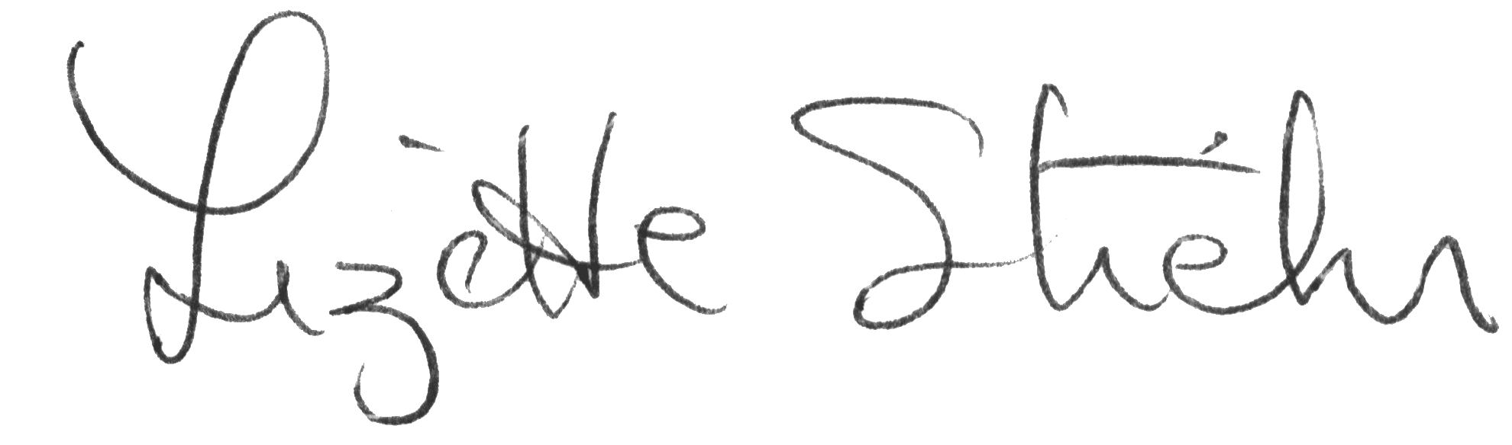
Lizette Stiehr
Executive Director, AADD

