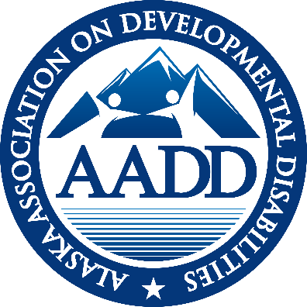

AADD
ALASKA ASSOCIATION ON DEVELOPMENTAL DISABILITIES

EXECUTIVE DIRECTOR REPORT
August 2021

SDS UPDATE
10% FMAP Increase -
AADD and other advocates continue to communicate to SDS that their plan for the majority of the 10% increased FMAP funds (27 million dollars) is not feasible. The plan to spend 89% of the funds to transition folks from institutions (API or out of state) to community service is not viable in the current workforce shortage both in terms of DSP’s to serve them and Care Coordinators to add very labor intensive individuals to their caseloads. Other projects would support workforce training toward professionalization of the workforce and companion services only for seniors to return to their home or a family member’s home.
Appendix K –The federal Public Health Emergency (PHE) has again been extended, now to October 18, 2021. When combined with Alaska’s approved 6 month extension of Appendix K, the earliest date the flexibilities would expire is April 18, 2022. And President Biden has said they plan to extend the PHE to the end of the calendar year, further extending the flexibilities offered through Appendix K. SDS has formally extended the use of simplified support plans to December, 2020.
Family Habilitation—SDS anticipates meeting internally on the Family Habilitation issue in August in order to prepare for further stakeholder engagement and dialogue. AADD made significant recommendations in the first round of stakeholder input including: 1) Grandfathering in group home providers that own their homes, 2) Allow providers to be become the Organized Health Care oversight Entity, 3) Increase the Family Habilitation Home rate, and 4) Define “live-in” staff in group homes. Letter containing AADD recommendations was attached to May’s monthly report.

Companion Services —The SDS plan for the 10% FMAP includes a small pilot for Companion Services limited to seniors in assisted living who wish to return to their own home or a family members home.
COST OF CARE REGULATION CHANGE
SDS hosted a Cost of Care webinar July 15th. At the end DPA announced that providers having to reduce their billings by the amount of the Cost of Care would be delayed.
Christina Davis, a Public Assistance Program Officer clarified the delay in implementation.
“Just to be clear, the revised state regulations that went into effect August 1st and DPA not imposing new cost of care or increasing cost of care during the Public Health Emergency (PHE) are actually two different subjects. Federal regulations require that we reduce our Medicaid payment to the provider by the amount of the recipient's cost of care, even if the cost of care isn’t paid to the provider. The state regulation changes that went into effect August 1st just aligned state regulations with federal regulations. Regarding the PHE, Alaska has chosen not to start or increase cost of care obligations during the COVID-19 PHE. At this time, we do not know when the PHE will end. Once the PHE declaration has expired, we will be implementing changes that were postponed during the PHE, including starting and increasing an individual’s cost of care. We will be notifying individuals and the facility in which they live at least 10 days prior to any increase in their cost of care obligation. This notice will also be sent to their care coordinator if a signed release has been received.”

MENTAL HEALTH TRUST AUTHORITY
Mental Health Trust Grant 8464.04 for FY 22 is for $65.000. This grant contains the same three general goals as last years. It is signed and approved.
- Advocate for a strong system and best practices through involvement with national trends and organizations. Funds will support Joe Macbeth as keynote speaker for face2face meeting in October.
- Change management support for leadership and Support for Agency Sustainability and Work Force Development.
Mental Health Trust Grant 8464.03 for FY21 was for $65,000. The grant has received an amendment for a 3 month extension to September 31, 2021. This will allow for the AADSP (Alaska Alliance of DSP’s) to meet for a strategic planning session.
Care Coordination Study – AADD has submitted a Letter of Interest for a $90,000 grant to research Care Coordination duties, caseloads and make recommendations. The Trust will review the request in mid-September and we will know about any potential awards in early October. An RFP has been drafted and reviewed by care coordinators and SDS.

HOT TOPICS
The Hot Topics call, August 26th was on COVID-19 current procedures with the spike in cases in Alaska. 32 providers participated and shared current policies concerning travel, masks, and vaccinations.

ADVOCACY Alaskans Together For Medicaid (ATFM) is a broad coalition of organizations that rely on Medicaid (including health, homelessness, food insecurity, Native Health, Mental Health Trust, Mat Su Health Foundation, ABHA, AADD and others). The group continues to meet weekly sharing legislative updates and federal information. Lizette and Michael generally attend.

ANCOR Briefings: ANCOR offered an hour long presentation on the State of America’s Direct Support Workforce data that was collected prior to the pandemic to document the workforce shortage back then. .
- 66% of providers are turning away new referrals
- 34% of providers are discontinuing Programs and Services
- 65% of Providers are delaying the launch of new Programs or services
- 69% of providers are struggling to achieve quality standards
- 40% of providers are seeing higher frequencies of reportable incident
- The average provider spends an addition $904,000 annually

CALENDAR
August 31, 2021 AADD Board meeting - 9 to 10
September 9, 2021 AADD Monthly Meeting - 11:00 to 12:00
September 16 2021 Compliance Group - 8:30 to 9:30
September 16 2021 CFO Group – 10:00 to 11:00
September 232021 Hot Topics – To be announced
October 19 & 20, 2021 Fall Face2Face meeting – offered virtually on zoom

SUMMARY OF SDS ALERTS
August 5, 2021 E-Alert: Congratulations to Jenn Crafton
August 6, 2021 E-Alert: Updates on COVID-19 Vaccines, Settings Guidance and the Delta Variant
August 12, 2021 E-Alert: Currently Active Flexibilities for Long Term Services and Supports to Continue
August 13, 2021 E-Alert: Clarification on Care Coordination Flexibilities
August 18, 2021 E-Alert: COVID-19 Vaccination Survey
August 23, 2021 E-Alert: Upcoming Webinar on Changes to Employment Services Regulations
August 24, 2021 E-Alert: Family ECHO tomorrow, Wednesday, August 25
August 24, 2021 E-Alert: File Name Restrictions when Using Chrome to Access Harmony
August 26, 2021 E-Alert: COVID-19 Booster Vaccinations Information for Congregate
Residential Settings.
August 26, 2021 E-Alert: Correction – File Name Restrictions when Using Chrome
August 27, 2021 E-Alert: Traumatic and Acquired Brain Injury Grant Awards Announced
August 27, 2021 E-Alert: SDS Reminds Providers of Federal Guidance on Non-Discrimination
August 27, 2021 E-Alert: Alaska Commission on Aging Meeting September 1-=2, 2021
August 316, 2021 E-Alert: FEMA Releases new Emergency Preparedness Resources for People with Disabilities.–

Respectfully submitted,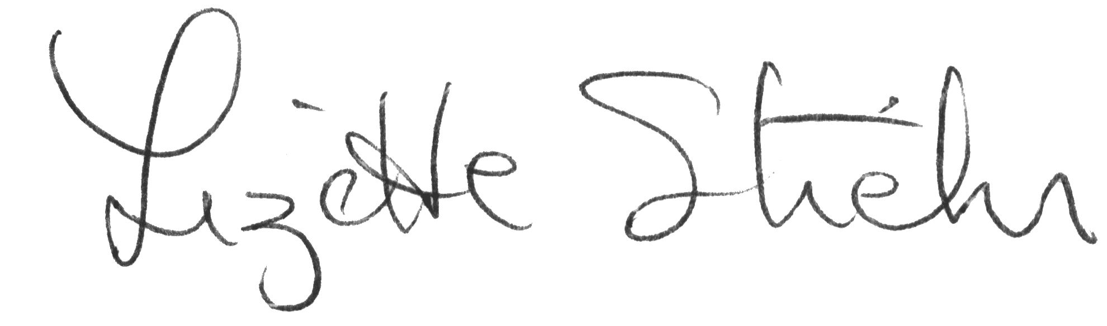
Lizette Stiehr
Executive Director, AADD

