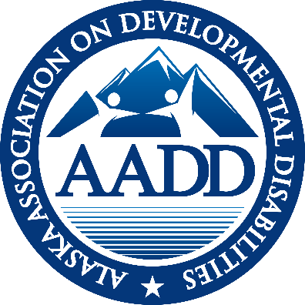

**AADD**

**ALASKA ASSOCIATION ON DEVELOPMENTAL DISABILITIES**

**EXECUTIVE DIRECTOR REPORT**

**FEBRUARY – 2022**

**Note Worthy News:**

* SDS revised 10% FMAP plan has been approved by CMS announced via E-Alert Feb. 2nd.
* Rate Rebasing Report is completed and submitted to the Commissioner and legislators

(shared with the membership, posted on the website and available by request)

* Maureen Harwood retires April 29th. She will be greatly missed.

**Attachments:**

1. February 25th AADD/Key Coalition letter to key legislators

**SDS UPDATE**

10% FMAP Increase -

CMS approved the revised the 10% FMAP Plan that SDS calls Alaska’s Revised Spending Plan for Distribution of ARPA Funds in early February. This plan will provide grant support to providers for workforce issues (such as salary or hiring bonuses). It will take a couple months to get the Provider Agreements and the entire process on line. The revised plan also include DSP career ladder funding and a data base for Critical Incident Reporting.

Level of Care Determination Regulations SDS reviewed all the public comment on the Level-of-Care Determination for Community First Choice, Home & Community-Based Waiver, & ICF/IID Services regulations and declared at this time they will not move forward with adding “substantial functional limitation” to the criteria for determining Level of Care. This is due to the opportunity to claim additional federal funds that are available during COVID could be jeopardized by changing eligibility criteria at this time.  When the opportunity to claim additional federal funds is no longer in place, SDS intends to reintroduce this regulatory amendment, to ensure all individuals with developmental or intellectual disabilities will be evaluated fairly and equitably, using the same criteria. This has significant implications for those currently eligible for TEFRA.

Appendix K –The federal Public Health Emergency (PHE) has been extended to April 16th. When combined with Alaska’s approved 6 month extension of Appendix K, the earliest date that Appendix K flexibilities would expire is October 16, 2022.

Numbers:

* 710 individuals on the Registry
* 350 of whom are active on ISW
* 2,070 individuals on or offered a spot on the I/DD waiver
* 585 individuals on or offered a spot on the ISW waiver
* FY22 drawn 64 individuals for IDD waiver
* FY22 drawn 91 individuals for ISW waiver

M**ENTAL HEALTH TRUST AUTHORITY**

Mental Health Trust Grant 8464.04 to AADD for FY 22 is for $65.000. This grant contains three primary goals.

1. Advocate for a strong system and best practices through involvement with national trends and organizations.

Funds have supported: Design Thinking, Alvin Law and Joe Macbeths all keynote speakers at our fall face2face virtual meeting. An ad campaign appreciating DSP’s during DSP Appreciation week in mid-September. And attendance at ANCOR’s conference in Miami for the Executive Director and two board members (Susan Garner and Cindy Hensley).

2. Change management support for leadership and Support for Agency Sustainability and Work Force Development.

AADD awarded a Rate Rebasing Study to Effective Health Design (Sandra Heffern). The report was completed and submitted to AADD January 30th. It documents the lack of rate reestablishment (regulatory language) of HCBS rates over the last 10 years, despite the fact that the regulations require state re-establishment every four years. A letter, with the study was submitted to the Commissioner on January 12th asking the administration to address that lack of compliance with an immediate 5% increase to rates. The 5% is the stop loss amount the regulations allow the rates to change. The Rate Rebasing study was shared with the membership and is available on the AADD website. There has been no response from the administration. On February 24, 2022 AADD and Key Coalition jointly sent the attached letter at the end of this report to key legislators and the administration.

Mental Health Trust Grant 13687 – A Study on Care Coordination in Alaska. – Adkison Consulting and Champney Consulting held in person focus groups in January to inform the state wide care coordination survey. The survey has been released with a 36% return already. Individual in-depth interviews with 26 care coordinators are being scheduled. AADD, the consultants and SDS are meeting monthly to strengthen the partnership needed to assure a quality product.

**MAT-SU FOUNDATION HEALTH FOUNDATION GRANT**

The Mat-Su health Foundation has awarded $15,000 to AADD for the development of 4 job preview videos to demonstrate what the job is like for DSP’s in multiple fields (IDD, Seniors, PCS). Two different groups of providers have met with Northwest Strategies to brainstorm the videos content. AADD continues negotiations with the Trust for an additional $15,000 in funds for this project.

**CFO GROUP**

The CFO group met in February with 15 persons in attendance. Discussion included: 1) Issues downloading RA’s, 2. Feedback from ORR cost studies?, 3. Certification, 4. Gems: grant reporting very tough, 5. COVID discussion.

CFO group recommended that the Business Acumen Toolkit be added to the AADD Website. It is a simple overview in five different videos of key financial management areas that are specific to organizations that provide home and community based Medicaid waiver services in Alaska. It can be found here: <http://www.aaddalaska.org/about-aadd/>

**HOT TOPICS**

Hot Topics calls in February were placed by the COVID group. Members of the Group edited a California Template called a COOP or Continuity of Operations Plan Emergency Plan, to make it more useful for Alaskan providers. It is available on the AADD website. Initially the group was hopeful it could be utilized as a “Crisis Standards of Care” that are utilized by hospitals when overwhelmed. But the document is more focused on individual providers’ plans. The Group plans to continue to meet and discuss what items need to be waivered (what regulations) in case of an emergency. And that asks the question of how to define such an “emergency.”

The next Hot Topics call is scheduled for March 17th. NADSP (Nationals Association of Direct Support Professionals) will present on their certification/training for DSP’s. AADD is hopeful that the SDS plan for a DSP career path, funded by the 10% FMAP funding, will incorporate the NADSP badge system through the Alaska Training Center. This would provide specific IDD training on top of the basic core competencies. We hope you will join us for this topic and ask all your questions and concerns about DSP certification.

**ADVOCACY A**laskans Together For Medicaid (ATFM) is a broad coalition of organizations that rely on Medicaid (including health, homelessness, food insecurity, Native Health, Mental Health Trust, Mat Su Health Foundation, ABHA, AADD and others).

HB265/SB 175, the Telehealth Bill has been submitted by Representative Sponholtz. It would allow for reimbursement (at the same rate) for remote Care Coordination and HCBS services. Under the payment section the bills specifically includes “(3) services covered under federal waivers or demonstrations”.

HB 292 SB 183 is a bill (sponsored by the SEIU union out of Washington state) to make it more difficult for SDS to reduce services.

**ANCOR**

Briefings: ANCOR continues to host a Friday morning briefing for all ANCOR members.

* ANCOR continues to be hopeful that the Build Back Better Act will move forward in some fashion. Their lobbyist reminds us that the Affordable Health Care act was dead in December but passed in March. He states March is when we will know if it will pass.
* Congress has funded the government with a March 11 deadline for the new budget. . Now Congress is focused on funding and the 12 spending bills that have to be in place to pass another omnibus spending bill.
* NCI (National Core Indicators) Staff Stability Report – 2020 was just released. You can find it here: <https://www.nationalcoreindicators.org/upload/core-indicators/2020StaffStabilitySurveyReport_FINAL.pdf>
* A bill to support DSP’s having their own SOC (Standard Occupation Code) is in congress.
* New poverty guidelines, in alignment with the 4.7% inflation rate have been released.

**CALENDAR**

March 1, 2022 Board Retreat

March 8, 2022 Care Coordination Group 10:30—11:30

March 9, 2022 COVID Group on COOP 11 to 12

March 10, 2022 Monthly AADD meeting—11 to 12

March 17, 2022 Compliance Group 8:30—9:30

March 17, 2022 CFO Group 10—11

March 17, 2022 Hot Topics—DSP Certification

March 29 & 30, 2022 AADD SPRING FACE2FACE –virtually

**SUMMARY OF SDS ALERTS**

February 4, 2022 E-Alert: Statewide Independent Living council of Alaska SILC board Meeting – Wednesday February 9th, 2022

**February 4, 2022 E-Alert: Alaska’s Revised Spending Plan for Distribution of ARPA Funds Approved by CMS**

February 8, 2022 E-Alert: Alaska LEND Program Seeks Applicants

February 9, 2022 E-Alert: Alaska’s Electronic Visit Verification System received Certification by CMS

February 10, 2022 E-Alert: Full Lives Conference (Virtual Event) to be held April 13-15, 2022

February 16, 2022 E-Alert: Frequently Asked Questions Received and Responses (FAQ #3) on ICF/IDD Services

February 24, 2022 E-Alert: Announcing the upcoming Peer Power Self-Advocacy Summit

February 25, 2022 E-Alert: Alaska’s Federal Fiscal Year 2022 Grant Application Under Part C of IDEA is Open for Public participation

February 25, 2022 E-Alert: 21 Annual Full Lives Conference for Direct Service Professionals and Care Coordinators to be held April 13 – 15, 2022

*Respectfully submitted,*

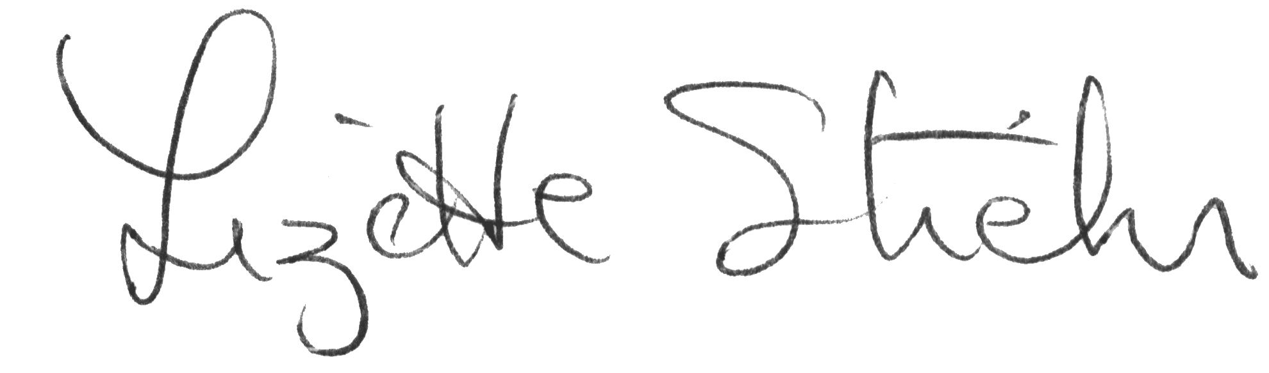

*Lizette Stiehr*

*Executive Director, AADD*

**With AADD and Key Coalition logo’s**

***To facilitate a united provider voice for best practices, advocacy, partnerships and networking.***

February 24, 2022

To: Chair and Honorable Members of the House Health and Social Services Finance Subcommittee

Re: Medicaid Budget Adjustment for Statutory and Regulatory Rate Compliance regarding rebasing (re-establishment) of Home and Community Based Services reimbursement

The Alaska Association on Developmental Disabilities, in partnership with the Key Coalition of Alaska, is requesting a Medicaid immediate re-establishment of rates for all home and community-based and personal care services retroactive to July 1, 2021. We are requesting the SFY2018 rates be adjusted by the “access” factor of 5% and inflated forward for each subsequent year based on the inflationary adjustments already in place.

Historically, the State of Alaska operated the Harborview institution in Valdez to house and provide services to Alaskans experiencing intellectual and developmental disabilities. In 1993, the State of Alaska began Alaska Medicaid Waivers to support individuals in their own communities, closing the institution in 1997 and drawing Federal Medicaid match to support the costs. Home and Community Based Services are significantly more cost effective than institutional services. For almost 20 years, service providers received a rate of reimbursement that was individualized to the support needs of the recipient. In 2004, the State of Alaska began the process of moving reimbursement to an aggregate rate, with a single state cost-based rate setting methodology using a similar approach to cost reporting and rebasing already in place for hospitals and nursing homes.

Rates for home and community-based and personal care services, governed by regulation 7 AAC 145.520 - Home and community-based waiver services payment rates, were implemented in 2011. Rates should have been re-established at least every four years (2014, 2018, 2022 and so on) using provider cost data collected for rebasing purposes.

In 2014 rates were not re-established. In 2018, rates were also not re-established based on governing regulations 7 AAC 145.525 - Re-establishing and adjusting payment rates in the department's Chart of Personal Care Services, Community First Choice Services and Waiver Services Rates. The 2018 re-establishment of rates did not occur due to implementation of cost containment measures by the Department of Health and Social Services. Yet, the targeted group of mandated providers submitted cost survey information to the Office of Rate Review which could have been used to re-establish rates in subsequent fiscal years. It should be noted that health facility rate rebasing continued as scheduled during the cost containment fiscal years (as governed by 7 AAC 150.160 – Methodology and criteria for approval or modification of a payment rate).

The cost survey data submitted for the re-establishment of rates in SFY18 are now outdated and no longer useful in determining adjustments. Our request to offer critical immediate rate relief for providers and to follow the intent of the regulations is to apply the 5% “access” factor to SFY18 rates and then apply existing inflation adjustments forward. This also offers a simple straight forward calculation for the Office of Rate Review. Utilizing the access factor ensures the 5% cap on rate increases that the Office of Rate Review would have applied to the cost survey data upholds the intended stop-loss factor.

AADD communicated this request to the Commissioner of Health and Social Services on January 12, 2022 conveying the dire financial situation many of our members are facing due to the impact of a decade without regulatory re-establishment of rates. The administration has not provided a response to this correction of apparent non-compliance with the established methodology. With the support of the Alaska Mental Health Trust Authority, AADD commissioned the rate study by Effective Health Design which was issued on January 25, 2022 and subsequently provided to the Commissioner. This report is attached for your reference.

Rates of reimbursement have clearly failed to keep pace with many state and federal mandates, regulatory changes, and other systemic changes that have occurred since home and community-based and personal care service rates were established through analysis of provider cost surveys in 2011. This failure covers multiple administrations but the emergency regulations issued by the current administration on June 28, 2019 in freezing rates for SFY20 also had the effect of derailing the Office of Rate Review from processing the cost surveys submitted by providers for rate rebasing using 2018 costs. The COVID-19 pandemic created additional strain on providers already struggling under the weight of unfunded mandates, and exacerbated an existing workforce shortage due to reimbursement rates insufficient to attract qualified workforce. Jared Kosin, Executive Director of the Alaska State Hospital and Nursing Home Association presented to the House Ways & Means Committee on January 27, 2022 this visual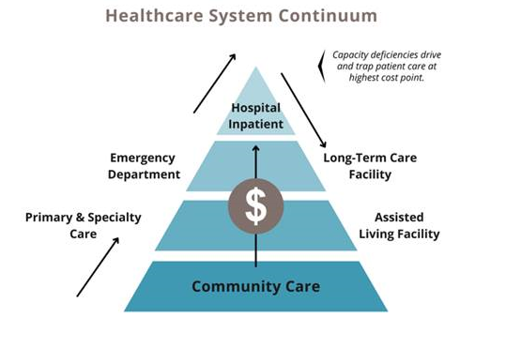

Clearly, the failure of a rate methodology in existing statutes and regulations to allocate Medicaid resource to the lower cost, community based supports “trap patient care at highest cost point”. This is not responsible stewardship.

We are asking this committee to urgently examine non-compliance with existing regulations and to introduce a Medicaid budget amendment that provides immediate and overdue rate relief.

Alaska Statute 47.05.270 requires the Department of Health & Social Services to submit an Annual Report to the Legislature by November 15 of each year on the status of reforms.

AK DHSS Annual Medicaid Reform Report FY2021 (issued November 15, 2021)

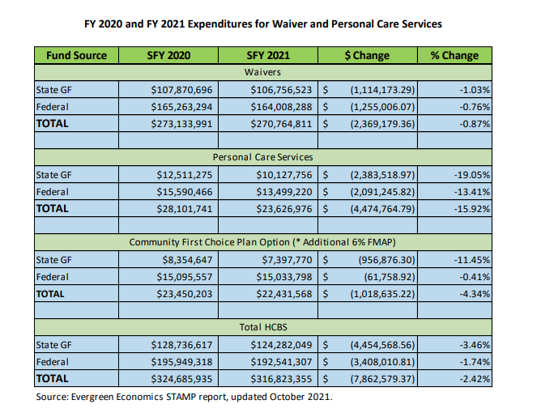

As an estimate using FY21 expenditures, a 5% access factor applied to

Waivers

|  |  |
| --- | --- |
| State GF | $               5,337,826 |
| Federal | $               8,200,414 |
| **Total** | $            13,538,241 |

Total HCBS

|  |  |
| --- | --- |
| State GF | $               6,214,102 |
| Federal | $               9,627,065 |
| **Total** | $            15,841,168 |

We are ready to provide supporting testimony during committee hearings, and plan to pursue discussions with the administration around the existing methodology as they relate to system sustainability and access to services.

Sincerely,

Amanda Faulkner Michele Girault

President, AADD President, Key Coalition of Alaska

cc. Commissioner Adam Crum

Deputy Commissioner Al Wall

Director, Senior and Disabilities Services John Lee

Executive Director, Office of Rate Review Marcey Bish

CEO, Mental Health Trust Steve Williams

Chair, Senate HSS Committee Senator David Wilson

Co-Chair, House HSS Committee Representative Liz Snyder

Co-Chair, House HSS Committee Representative Tiffany Zulkosky