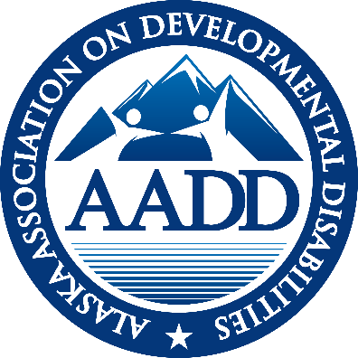

AADD
ALASKA ASSOCIATION ON DEVELOPMENTAL DISABILITIES

EXECUTIVE DIRECTOR REPORT
June – 2022

Note Worthy News:
- Kim Champney is oriented and set to begin as AADD Executive Director July 1 (well really July 5th with the holiday)
- The budget is out and the Commissioner texted David Parish to say that the 10% rate increase for HCBS and PCS services and the General Relief fund will stand. Watch for an imminent E-Alert with more information.
- AADD mailing address is moved to Juneau. Please note this change as you mail in your AADD dues.
AADD
P.O. Box 20874
Juneau, AK 99802
- The Governor has appointed Kim Kovol as the acting Commissioner for Alaska’s new Department of Family and Community Services. She was previously with Bean’s Café. Adam Crum will retain the Commissioner of the Department of Health (overseeing SDS).

SDS UPDATE
‘
ARPA Funds
SDS hosted a webinar June 3rd, walking providers through the application process for the funds they have been notified are available for their organization. The email to use for any questions concerning the funding is: HSS.DSDS.ARPA@alaska.gov. The first applications are due May 30th. The second allocation will allow you to collect reimbursement for costs from 4.1.21 to 3.31.22.
The Pilot Project for DSP certification through the Alaska Training Cooperative (ATC) will support a cohort of 175 Alaskan DSP’s through the NADSP (National Alliance of Direct Support Professionals) badges certification process. ATC is working on who will be eligible for the funding support and has released a survey to help them determine the cohort makeup. ATC has provisional acceptance as accredited training facility with NADSP. An Advisory Board has started meeting. Cindy Hensley (Vice President of AADD) and Kim Champney sit on that Advisory Board. Watch for the applications to come out.
Appendix K –It appears likely that the current federal Public Health Emergency (PHE) will again be extended in July when the current one expires. Alaska has an approved 6 month extension of Appendix K flexibilities after the PHE expires. This means that families, as paid providers, will be able to continue to provide services until 6 months after the end of the PHE. HCBS services will not allow family members to be paid caregivers after the end of the Appendix K extension. Personal Care services and CFC (Community First Choice) services will not extend family members as care givers past the end of the PHE (no Appendix K extension applies) because they are authorized separately under the 1135 waiver.
The flexibilities of Appendix K that have been incorporated into Alaska regulations and will remain in place after Appendix K ends include:
- Ist Aid and CPR certification from online courses
- Electronic signatures
- HCBS distance services (limited)
- Day habilitation in residential settings (limited)
- Care Coordination requiring only 2 visits per year in person
- Respite care can be provided while parents are working.
Numbers:
- 478 on the DDRR (waitlist)
- 562 (was 537 last month) ISW Recipients
- 2,083 (was 2069 last month) total IDD recipients
- 113 drawn for the year for IDD
- 106 drawn for the year for ISW waiver

MENTAL HEALTH TRUST AUTHORITY
Mental Health Trust Grant 8464.05 for FY 23 for AADD has been awarded for $65,000. The goals remain focused on best practices and national trends, workforce and sustainability of the system.
Mental Health Trust Grant 8464.04 to AADD for FY 22 is now closed out. The final report has been submitted to the Trust. Accomplishments for FY22 include:
- Advocate for a strong system and best practices through involvement with national trends and organizations. Funds have supported:
- Design Thinking, Alvin Law and Joe Macbeth’s keynote speeches at our fall face2face virtual meeting.
- Amanda Rich and Anna Thomas as keynote speakers at our spring virtual face2face meeting.
- An ad campaign appreciating DSP’s during DSP Appreciation week in mid-September.
- And attendance at ANCOR’s conference in Miami for the Executive Director and two board members (Susan Garner and Cindy Hensley).

2. Change management support for leadership and Support for Agency Sustainability and Work Force Development.
- The Rate Rebasing Study, by Effective Health Design (Sandra Heffern) was funded through this grant. The report documents the lack of rate reestablishment (regulatory language) of HCBS rates over the last 11 years, despite regulations requiring their re-establishment every four years.
- Funds have been utilized for Champney Consulting to support AADSP (Alaskan Alliance for Direct Support Professionals)
- Funds were added to the Mat-Su Health Foundation Grant to support the development of job preview videos for DSP’s. DSP’s have been filmed and editing started resulting in the need for additional footage of supported employment. They have requested a 3 month extension past the June 30 deadline.
Mental Health Trust Grant 13687 – A Study on Care Coordination in Alaska. A 3 month extension of this grant has been approved by the Trust. While the data is all collected, a final draft will take additional time. AADD, the consultants and SDS continue to meet monthly to strengthen the partnership needed to assure a quality product.
MAT-SU FOUNDATION HEALTH FOUNDATION GRANT The Mat-Su Health Foundation has approved a 3 month extension to allow Northwest Strategies to develop some additional footage around supported employment in the 4 different job preview videos to demonstrate what the job is like for DSP’s in multiple fields (IDD, seniors, PCS).
CFO GROUP
The CFO Group did not meet in June.

COMPLIANCE GROUP
The Compliance group met June 23rd very briefly. Participation was limited due to summer in Alaska.

HOT TOPICS / COVID GROUP
Hot topics/COVID Group met on June 2nd to draft Emergency procedures for a disaster. A June 30thmeeting was well attended by Integrity, SDS, providers and Licensing. The group will begin to draft procedures for providers and the state to follow in case of an emergency based on residential services. The next meeting in July will begin the process of mapping out a process.

DD COLLABORATIVE
The DD Collaborative will meet in July under the new Chair: Roy Scheller. If you are interested in joining this group email Roy Scheller at rscheller@hopealaska.org

ADVOCACY Alaskans Together For Medicaid (ATFM) is a broad coalition of organizations that rely on Medicaid (including health, homelessness, food insecurity, Native Health, Mental Health Trust, Mat Su Health Foundation, ABHA, AADD and others). ATFM was instrumental in getting the HB265/SB 175, the Telehealth Bill has passed and are now planning a bill signing.
ATFM met with the major Department staff (Commissioner, Deputies and staff) around the separation of the Department. Because of the split of the Department, no regulations have been released as the separation was authorized and finalized on to July 1. I asked about the possibility of our Flexibilities Made Permanent Regulations (related to Appendix K that we commented on in January) that we need before the end of the PHE and the Appendix extension, I was assured the staff person had set a goal of September for those regulations. The organizational charts for both Departments can be viewed at https://dhss.alaska.gov/Commissioner/Documents/reorganization/orgchart. Adam Crum will retain the Commissioner position at the Department of Health which hosts SDS.

ANCOR
Briefings: ANCOR hosts a Friday morning briefing for all ANCOR members at 8:30 AK time. ANCOR also hosted a State Share call following a survey of all states. Top three issues are:
- 14 (c) Certificates (allowing salaries below minimum wage) – Already eradicated in Alaska
- Setting Rule full implementation March of 2023 –Without an institution, Alaska’s Transition Plan is fully approved
- Waiver issues and flexibilities - Where Alaska is working

CALENDAR
July 5, 2022 AADD Board meeting 9:00 – 10:00
July 5, 2022 Care Coordination Group 10:30—11:30
July 14, 2022 AADD Monthly membership AADD meeting 11:00 to 12:00
July 21, 2022 Possible Compliance Group 10:00 – 11:00 and CFO Group 10 – 11
July 26, 2022 DD Pride statewide from 12 to 1

SUMMARY OF SDS ALERTS
June 1, 2022 E-Alert: Reminder: National Core Indicators Staff Stability Survey
June 2, 2022 E-Alert: Reminder: AARP Direct Support Professional Incentive Webinar Tomorrow
June 10, 2022 E-Alert: HCBS Waiver Provider Poll
June 13, 2022 E-Alert: New Dementia Resource Guide Available
June 14, 2022 E-Alert: Reminder: Federal Public Health Emergency Remains in Effect
June 21, 2022 E-Alert: Reminder: HCBS Provider Poll – Responses Due Friday, June 24, 2022
June 24, 2022 E-Alert: Clarification: DHCS Requires Place of Service and Telehealth Modifiers for Care Coordination Starting march 1, 2022
June 28, 2022 E-Alert: SDS Webpage Access workaround
June 29, 2022 E-Alert – DSP Incentive Fund Application Deadline

Respectfully submitted,
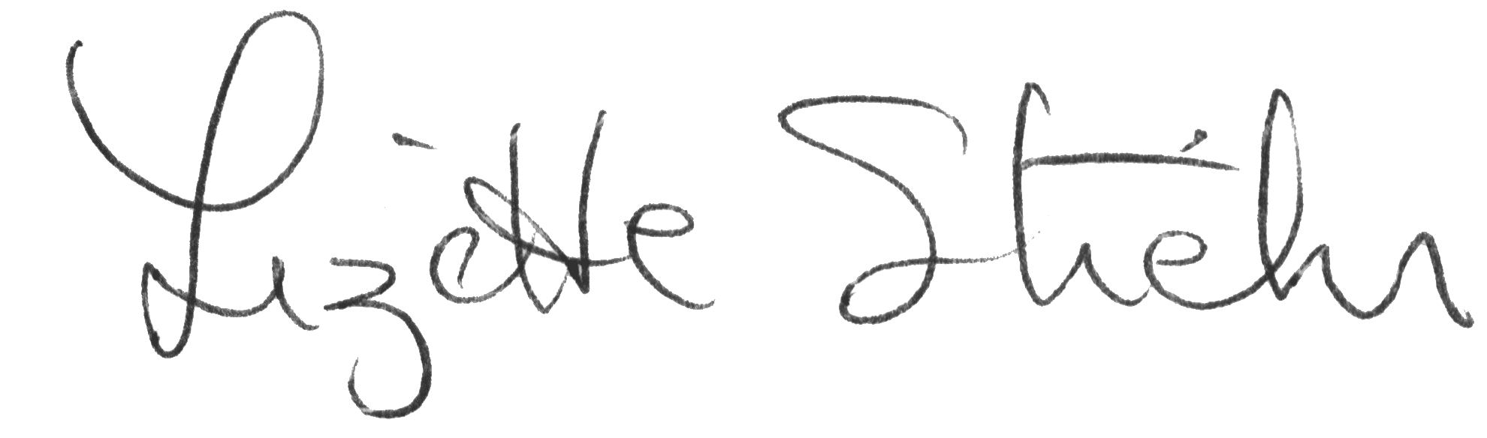
Lizette Stiehr
Executive Director, AADD

