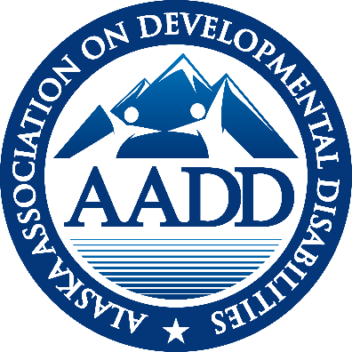

AADD
ALASKA ASSOCIATION ON DEVELOPMENTAL DISABILITIES

EXECUTIVE DIRECTOR REPORT
May – 2022

Note Worthy News:
- The 32 million legislative appropriation for HCBS and PCS services would mean a 10% rate increase for HCBS and PCS service providers. It includes a stated intent of a 10% rate increase for DSP’s. This assumes the Governor does not veto that line item.
- The legislature approved 20 additional draws (in addition to the 50 per year) and a 5 year tudy on how to eradicate the waitlist
- Patrick Reinhart is back as acting Executive Director of the Governor’s Council on Special Education and Developmental Disabilities. Myranda is on administrative leave.

Attached
- Letter send to the Governor supporting the 32 million dollar appropriation for HCBS and PCS services.

SDS UPDATE
Rate rebasing
ORR is 90% done with their desk audit. They have finished 20 our of 24 cost surveys. By May 20th they should have approval for their next steps. The 10% rate increase in the legislative appropriation overrides the 5% stop loss in the regulations on rates.
‘
ARPA Funds (aka 10% FMAP Increase)
On June 3rd SDS will host a webinar walking providers through the application process for the funds available for their organization. The definitions outlining what funds can be reimbursed was contained in an E Alert May 20 (Friday) at 3:00 pm. The first round of payments will be for expenses in the base year 4.1.20 to 3.1.21. You may not collect for expenses reimbursed through other funding (PPP, PRF etc.). If you do not have any costs for that first base year that were not covered APPLY IMMEDIATELY FOR 0 DOLLARS. IF YOU DO NOT APPLY, THE FUNDS ALLOCATED TO YOUR PROGRAM WILL BE DISSIMINATED TO OTHERS IN THE SECOND ALLOCATION. The second allocation will allow you to collect reimbursement for costs from 4.1.21 to 3.31.22. The faster the applications are submitted and processed, the quicker the state will be able to reallocate the remaining funds for that second base year.
The Pilot Project for DSP certification through the Alaska Training Cooperative (ATC) will support a cohort of 175 DSP’s in Alaska through the NADSP (National Alliance of Direct Support Professionals) badges certification process. ATC is working on who will be eligible. Originally the thought was only those DSP’s who have been in their position for less than 18th months would be eligible. They have not made a formal decision. ATC has provisional acceptance as accredited training facility with NADSP. There will be fiscal support at differing levels of badge attainment for both the DSP and the provider organization. An Advisory Board has started meeting. Cindy Hensley (Vice President of AADD) and Kim Champney sit on that Board. Watch for the applications to come out.
Appendix K –Bloomberg news reports that Health and Social Services plans to extend the federal Public Health Emergency (PHE) again in July. CMS has confirmed that intention with ANCOR as well. Alaska did not received the 60 days’ notice promised to states prior to the PHE expiring on May 12th , when it would have been expected if the PHE were to expire in July. Alaska has an approved 6 month extension of Appendix K flexibilities after the PHE expires. This means that families, as paid providers, will be able to continue to provide services until 6 months after the end of the PHE. HCBS services will not allow family members to be paid caregivers after the end of the Appendix K extension. Personal Care services and CFC (Community First Choice) services will not extend family members as care givers past the end of the PHE because they are authorized separately (not under Appendix K) under the 1135 waiver.
The flexibilities of Appendix K that have been incorporated into Alaska regulations and will remain in place after Appendix K ends include:
- Ist Aid and CPR certification from online courses
- Electronic signatures
- HCBS distance services (limited)
- Day habilitation in residential settings (limited)
- Care Coordination requiring only 2 visits per year in person
- Respite care can be provided while parents are working.
Legislation of interest -
HB 133—ABLE Act—Passed into law
HB265-SB175—Telehealth Bill—Passed into law
HB172/SB124—Crisis Now—Passed into law
HB 182/SB92—Bill by union—Did not pass
HB 98—Adult Home Care (was foster care) - Did not pass
Numbers:
- 537 ISW Recipients
- 2,069 total IDD recipients
- 10 drawn in May for IDD
- 40 drawn for ISW waiver

MENTAL HEALTH TRUST AUTHORITY
Mental Health Trust Grant 8464.04 to AADD for FY 22 is for $65.000. This grant contains two primary goals. AADD has requested a 3 month extension of the grant to accommodate additional filming on the job preview videos to include supported employment.
- Advocate for a strong system and best practices through involvement with national trends and organizations. Funds have supported:
- Design Thinking, Alvin Law and Joe Macbeth’s keynote speeches at our fall face2face virtual meeting.
- Amanda Rich and Anna Thomas as keynote speakers at our spring virtual face2face meeting.
- An ad campaign appreciating DSP’s during DSP Appreciation week in mid-September.
- And attendance at ANCOR’s conference in Miami for the Executive Director and two board members (Susan Garner and Cindy Hensley).

2. Change management support for leadership and Support for Agency Sustainability and Work Force Development.
- The Rate Rebasing Study, by Effective Health Design (Sandra Heffern) was funded through this grant. The report documents the lack of rate reestablishment (regulatory language) of HCBS rates over the last 11 years, despite regulations requiring their re-establishment every four years.
- Funds have been utilized for Champney Consulting to support AADSP (Alaskan Alliance for Direct Support Professionals)
- Funds were added to the Mat-Su Health Foundation Grant to support the development of job preview videos for DSP’s. DSP’s have been filmed and editing started resulting in the need for additional footage of supported employment. They have requested a 3 month extension past the June 30 deadline.
Mental Health Trust Grant 13687 – A Study on Care Coordination in Alaska. – Adkison Consulting in deep in data analysis and report writing for the report due June 30, 2022. AADD, the consultants and SDS continue to meet monthly to strengthen the partnership needed to assure a quality product.
MAT-SU FOUNDATION HEALTH FOUNDATION GRANT
The Mat-Su Health Foundation has awarded $15,000 to AADD for the development of 4 job preview videos to demonstrate what the job is like for DSP’s in multiple fields (IDD, seniors, PCS). Northwest Strategies has filmed DSP’s and started editing for final videos.

CFO GROUP
The CFO Group met May 19th with 12 in attendance. The discussion included:
- ORR update – one provider recently received a letter asking questions about their 2020 cost survey.
- The Self audit due December 31st
- Discussion of respite care costs exceeding billing rate and providers no longer offering daily respite that can cost up to $1,100 for staff overtime and reimburses at $300 for the day. Other providers see daily respite in their recipient plan but it isn’t utilized.’
- EVV was a topic.
- There was a request for another future joint meeting with Compliance.

COMPLIANCE GROUP
The Compliance group met May 19th with 11 attendees. The discussion included:
- Provider self-audit – discussed updated sheet of links Susan Garner developed and the format for pulling random billings (Doug Jones responded with their FAQ).
- DEI (Diversity, Equality and Inclusion) – Is training happening? The Arc has a Human Right Committee and their orientation contains information of DEI.
- Discussion of OSHA standards and organizations policies reflecting them.
- CIR (Critical Incident Reports) training of staff is required every two years.

HOT TOPICS / COVID GROUP
Hot topics/COVID Group met on May 19th with Craig Baxter from licensing, John Lee and Tony Newman from SDS and a small group of providers. Craig stated he is leaving in a month to return to his outside roots. The group discussed the need for a planned emergency response in case of a disaster. The state was supportive of a checklist for providers to follow in case of a disaster. The meeting is scheduled for June 2 to develop a draft checklist prior to meeting with the state again.

DD COLLABORATIVE
The DD Collaborative met May 5th The large coalition of stakeholders, committed to moving the Shared Vision forward. The new officers for FY23 are Chair: Roy Scheller, Vice Chair: Maggie Winston and Secretary: Cindy Hensley. The Charter Agenda allowed for the preview of an excellent video developed through Stone Soup for parents of children with disabilities. Michele Girault asked about questions to ask parents in listening sessions such as about how to help parents understand their options as their children approach adulthood and what their plans ae as they age. SDS continues on their path studying person centered services. If you are interested in joining this group email Roy Scheller at rscheller@hopealaska.org

ADVOCACY Alaskans Together For Medicaid (ATFM) is a broad coalition of organizations that rely on Medicaid (including health, homelessness, food insecurity, Native Health, Mental Health Trust, Mat Su Health Foundation, ABHA, AADD and others). They were instrumental in getting the HB265/SB 175, the Telehealth Bill has passed. They are meeting with the administration once again to discuss the Department split with Adam Crum as the Commissioner of the Department of Health that includes SDS. The organizational charts for both Departments can be viewed at https://dhss.alaska.gov/Commissioner/Documents/reorganization/orgchart.

ANCOR
Briefings: ANCOR continues to host a Friday morning briefing for all ANCOR members.
- ANCOR continues to work with NADSP for collecting sponsors for a bill that would require a separate SOC (Standard Occupational Code) for DSP’s
- The budget reconciliation bill (taking the place of the Build Back Better Act) is hoping to resolve the negotiations in June with an additional 1.5 Billion dollars for HC BS services

CALENDAR
June 2, 2022 AADD Board meeting 9:00 – 10:00
June 2, 2022 COVID Group – 11:00 – 12:00
June 7, 2022 Care Coordination Group 10:30—11:30
June 9, 2022 AADD Monthly membership AADD meeting 11:00 to 12:00
June 23, 2022 Compliance Group 10:00 – 11:00
No CFO Group meeting in June

SUMMARY OF SDS ALERTS
My 4, 2022 E-Alert: Presentation on Electronic Visit Verification (VV) for Home Health Care Services
May 20, 2022 E-Alert: AARP Direct Support Professional Incentive Fund - UPDATE
May 26, 2022 E-Alert: Direct Service Provider (DSP) Certifications Pilot – Information and Updates
May 27, 2022 E-Alert: Upcoming Application Period for Exceptions to Conflict free Care Coordination

Respectfully submitted,
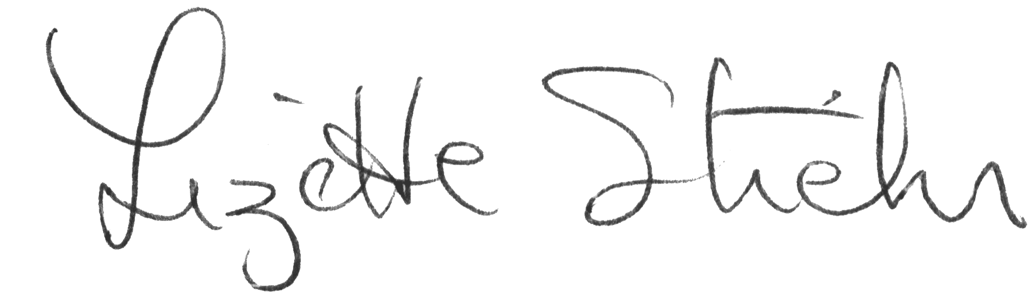
Lizette Stiehr
Executive Director, AADD

On Letterhead
To facilitate a united provider voice for best practices, advocacy, partnerships and networking.

May 26, 2022

Dear Governor Dunleavy,

The legislative appropriation of 32 million dollars allocated for Home and Community Based Services (HCBS) and Personal Care Services (PCS) is critical to the sustainability of those programs. The legislative intent is that DSP’s (Director Support Professionals) will receive a 10% increase in pay, which is sorely needed.
DSP’s (Direct Support Professionals) are key to the services provided to individuals who experience developmental disabilities and those aging in the Home and Community Based Service and Personal Care Service programs. Currently the wages that rates support are being exceeded by MacDonald’s and Lowe’s, while the responsibility and skills they need vastly exceed those to sell hamburgers or lumber.
COVID has significantly and negatively impacted the availability to hire DSPs. A survey of providers in 2021 demonstrated that 33% to 66% of authorized services are not being offered due to a lack of staffing. An average of 50% of direct services shifts, typically offered by DSP’s (Direct Support Professionals) are being covered by supervisors, managers and CEO’s of organizations. Turnover rates, due to burn out from extra shifts and concerns about COVID, have risen from the national average of 45% to rates as high as 65%. They need to receive higher wages.
Rates have not been adjusted for Home and Community Based providers since they were developed in 2011 based on costs inflated forward from 2007 costs. That is 11 years with just small inflationary increases amounting to 18%. During that same time period the Alaska Medical Care consumer index increased 46.92%. During that time period of no rate adjustments there were numerous unfunded mandates added to the work of the HCBS system such as: electronic records, the Affordable Care Act, completion of annual cost surveys for rate rebasing, self-audits, conflict free care coordination, EVV, accreditation requirements, elimination of grant funding, increased training requirements, requirements for note review within 72 hours or 14 days, CMS settings requirements, the MMIS conversion in 2013 and a cap on day habilitation hours.
This appropriation is seriously needed to continue the work of providing quality, person directed services to some of your most vulnerable Alaskans who share a vision, which is in statue, of a flexible system leading to a meaningful life in the community for them. Please continue to support these individuals living across Alaska by keeping the 32 million dollar appropriation in the budget. Thank you for your hard work on behalf of Alaskans.
Sincerely,
Lizette Stiehr,
Executive Director, AADD

